Thinking Day Egg Hunt
- Get 2 poster boards and plastic Easter eggs
- Print out the following pages. There are two types of pages, the fact strips and topic titles. Put the topic title pages on the poster board, 4 to a board.
- Cut the facts strips of paper
- Stuff the eggs with one fact strip each (and a piece of candy if you like), and hid the eggs before the meeting.
- At the meeting, have the egg hunt
- Match the facts with the title on the poster board, and tape the strip up on the poster.
Juliette Low World Friendship Fund

"In memory of Juliette Low, founder in America of the Girl Scouts, let a fund be raised … for the promotion of Girl Scouting and Girl Guiding throughout the world, as a contribution toward world peace and goodwill…”

Supports fun, educational programs that foster international friendships among Girl Scouts from 140 nations.

Donations support service projects, training and international opportunity events, as well as exchange visiting programs.

supports the exchange of Girl Scout trainers between countries with established member organizations, as well as between those where Girl Scouting is just beginning.

sponsors special projects to fight illiteracy, hunger and disease and sends aid to Girl Scouts and Girl Guides affected by natural disasters.

"Not only did Juliette attend them [International Conferences] herself, she made it possible for other people to attend them by herself defraying the expenses of delegates from countries where the Guide movement was but just starting and was hampered by lack of funds."

Juliette and her friends firmly believed that by spreading goodwill and friendship among children from different nations, they could bring about world peace.

started in 1927, the year Juliette Low died, to honor her dream of spreading Girl Scouting around the world.

Girl Scouts of the USA, Juliette Low World Friendship Fund,
P.O. Box 19611A, Newark, NJ 07195-0611

The Fund enables Girl Scouts from the United States to live and work with Girl Guides abroad–at camps, with families, and at the four world centers operated by the World Association of Girl Guides and Girl Scouts.

When Girl Scouts give to the Fund and reaffirm their Promise, they not only "contribute toward world peace and goodwill," but also strengthen their ties with Girl Scouts and Girl Guides all over the world.

Our Cabaña

Cuernavaca, Mexico Web site: http://www.ourcabana.org

opened in July 1957 and has since welcomed over 65,000 Girl Guides and Girl Scouts from around the world.

offer youth programs to encourage international friendship and team building.

The Our Cabaña logo is also the symbol for the city of Cuernavaca. The drop of water is symbolic of our communication with both the Girl Guiding and Girl Scouting movement, and the community of Cuernavaca. Like the tree, our movement has life and will continue to grow as it is nourished by the water. The parts of the logo symbolize: roots - of friendship which start at Our Cabaña and grow deep. trunk - strength and continual growth of the Girl Guiding and Girl Scouting movement. branches - one for each part of the original promise. drop of water - Aztec symbol of life and a pre-Hispanic symbol of communication.

Special sessions on Mexican Arts and Culture will immerse you in Mexico's vibrant cultural heritage and let you bring a piece of your trip home with you.
Pax Lodge

London, England Web site: http://www.paxlodge.org

accommodate 59 people in 2, 3 and 4 bedrooms. There is a dining room and kitchen, a lobby lounge, a library and resource centre, a shop, a tv room, a guest kitchen, staff and resident wings, laundry facilities, as well as two conference rooms.

Pax Lodge was chosen as the name for the new World Centre in London for historic reasons. The family homes of Lord and Lady Baden-Powell were called Pax Hill and Paxtu. The Latin word for Peace is Pax and with its history, Pax was an appropriate choice. The property where Olave Centre is situated was called Rosslyn Lodge when it was home to the Earl of Rosslyn and to keep a connection with the old name, Lodge was chosen.

Pax Lodge in London, England Sessions focus on English history and culture, with a special emphasis on the roots of Girl Guiding/ Girl Scouting.
Our Chalet

Adelboden, Switzerland Web site: http://www.ourchalet.ch

Swiss chalet with stunning picture postcard views of Adelboden and the surrounding mountains.

has single, twin, triple and dormitory bedrooms, a large family style dining room, a shop, laundry room, ski room, telephone, a quiet room for reading or making jigsaws and a music room for playing games or having a party!

In the winter, Adelboden offers skiers and snowboarders of any ability, from beginner to advanced, three extensive and safe ski areas. It also has an excellent ski school and ski hire facilities, and apres ski activities include ice skating, curling, sledging, swimming, and a moonlit evening walk to a mountain hut for ice creams or hot chocolate.

In the summer, guests can explore mountain trails and alpine paths, discover the extraordinary flora and fauna of the area, paraglide over Adelboden or fly to the Matterhorn in a light aircraft, and take in the breathtaking beauty of the Bernese Oberland. As well as walking and hiking, guests can enjoy day trips to a variety of local towns and attractions and try their hand at the new range of extreme sports on offer.

is on the outskirts of Adelboden, Adelboden is a small town at the end of a valley in the Swiss Alps. It is in the Bernese Oberland, just 30 minutes from Interlaken and less than an hour from Switzerland¹s capital, Bern.

Sangam Pune, India Web site: http://www.sangamwagggs.org.uk*

youngest of the four World Centres of WAGGGS.

The word "Sangam" means Coming Together.

share experiences as well as the culture and traditions of India and of their homelands.

located in the city of Pune, which is in the state of Maharashtra, in India. Pune is about 190 km (120 miles) from Mumbai - what was formerly Bombay - on the west side of the country.

In Sanskrit, the word "Sangam" describes a place where three rivers meet. It also means "coming together" and here at Sangam Girl Guides and Girl Scouts from many nations can come together to experience international living at its best and to forge lasting friendships.

event topics emphasize cultural sharing, common links in Guiding/Girl Scouting and the rich cultural heritage of India.

Sangelee

takes the first part of Sangam and the first part of elephant! Also that the motion lines near her feet remain in all drawings, because it is important to give the feeling of action to Sangelee. She is not just a static figure, but a dynamic mascot leading us on to more fun and greater achievements at Sangam!
Robert Stephenson Smyth Baden-Powell, Olave, Lady Baden-Powell,

Letters from boys to B-P set him of how he could do more to help boys and how they could best be trained. He had had many years of experience in training soldiers. Why not draw up a scheme of training for all boys on the same lines? Why not train boys as peace scouts, ready at all times to help others?

B.-P.'s book Aids to Scouting was being used by youth leaders and teachers all over the country. In 1907 he held an experimental camp on Brownsea Island, Poole, Dorset, to try out his ideas. He brought together 22 boys, some from public schools and some from working class homes, and put them into camp under his leadership. The camp was so encouraging, and the boys so enthusiastic - it was indeed a thrill to be trained by the
defender of Mafeking! - that B.-P. decided to make the general scheme more widely known.

In 1910, with his sister Agnes Baden-Powell (1858-1945), he founded the Girl Guides.

In 1909, a Boy Scout rally was held at Crystal Palace in London, and Baden-Powell was taken aback when a number of girls attended, proclaiming themselves to be girl Scouts. He decided that if they wanted to join in, they should have their own name and Movement, and a programme suited to their needs.

Baden-Powell chose the name Girl Guides after the famous corps of guides in India who were "distinguished for their general handiness and resourcefulness under difficulties, and their keenness and courage..."

Baden-Powell felt that the Movement for girls should be run by women, so in 1910 he asked his elder sister Agnes to undertake the work of adapting his book Scouting for Boys, for use with girls. That year the Guide Movement was formally founded, with the establishment of the Girl Guides Association (United Kingdom).

Olave Baden-Powell was appointed UK Chief Commissioner in 1916 and in 1917 she began to organize The Girl Guide Movement in Sussex, UK. In 1918, her title, UK Chief Commissioner, was changed to UK Chief Guide.

until she died in 1977, was known throughout the world as World Chief Guide.

Girl Scouts was actually first headed by Agnes Baden-Powell, the sister of the Boy Scout founder. Later, Olave Baden-Powell, Lord Baden-Powell's wife, got involved and became the only person to hold the title of World Chief Guide.

USA is one of the few countries who use the Girl Scouts term. Although the first ones called themselves "scouts", Lord Baden-Powell chose the name "Girl Guides" after a famous corps in India.

In 1910, the official movement, Girl Guides Association was founded.

By 1912 Juliet Low founded the USA Girl Scouts (note according to WAGGS, USA uses "scouts" because "guides" was an unacceptable term die to its common US definition of an indian hunter.)

her vision saw Guiding become the largest organization for girls and women ever seen.
WAGGGS

There were 26 Founder Members of WAGGGS - Australia Belgium Canada Czechoslovakia Denmark Estonia Finland France Hungary Iceland India Japan Latvia Liberia Lithuania Luxembourg Netherlands New Zealand Norway Poland South Africa Sweden Switzerland UK USA Yugoslavia

Each WAGGGS Member Organization chooses how it believes it can best promote this, taking into account its culture and the needs of its young people. Some choose to work with girls alone in a single sex environment in order to break down stereotypes and to give girls and young women the confidence to take their place in society. Other Member Organizations prefer to work with mixed groups to enable young women and young men equal partnership within their units.

The World Association of Girl Guides and Girl Scouts is an organization run by women for girls and young women.

Because of our membership in the World Association of Girl Guides and Girl Scouts (WAGGGS), Girl Scouts of the USA is connected to 139 other Girl Guide/Girl Scout national associations worldwide. These connections offer GSUSA members opportunities for international friendship and understanding through many fun and educational activities outside the United States.

Girl Guide/Girl Scout organizations worldwide are generally connected by the same ideals and principles. The notion of forming an international movement started in the early 1900s, and the World Association of Girl Guides and Girl Scouts was officially formed in 1928..

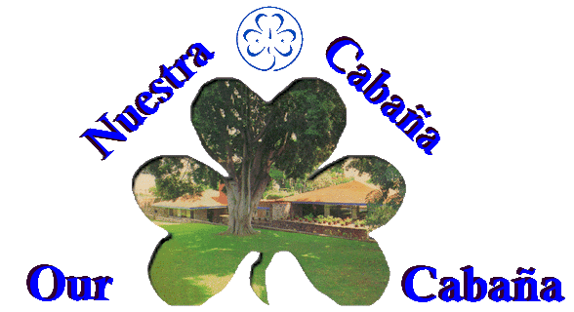
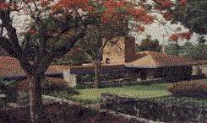
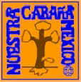
Pax Lodge
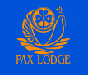
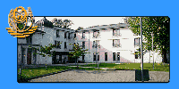
Our Chalet

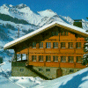
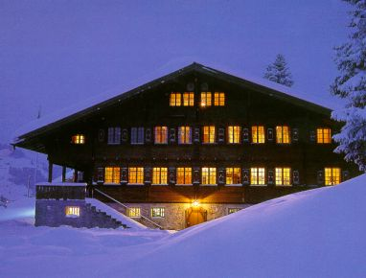

Sangam
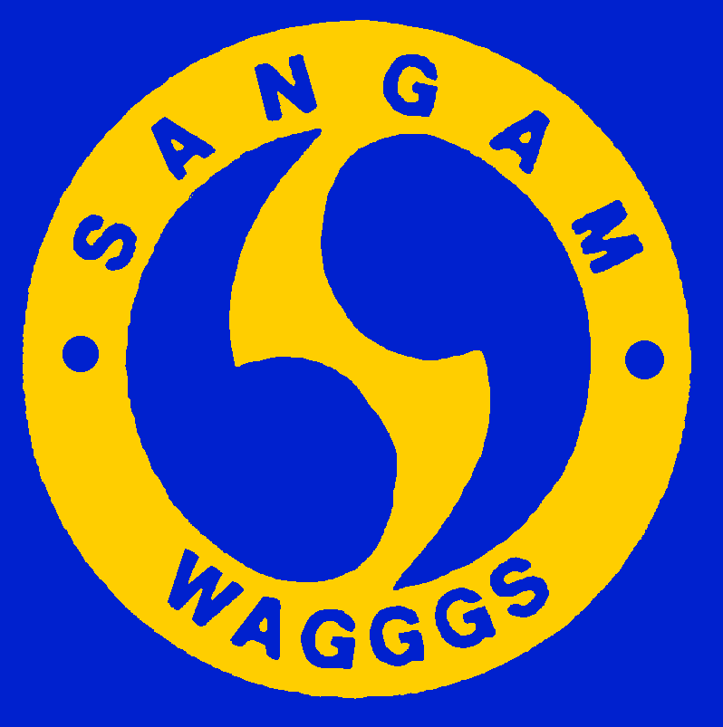
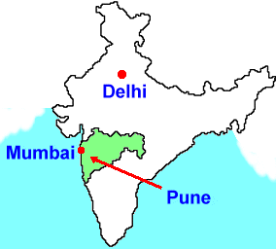

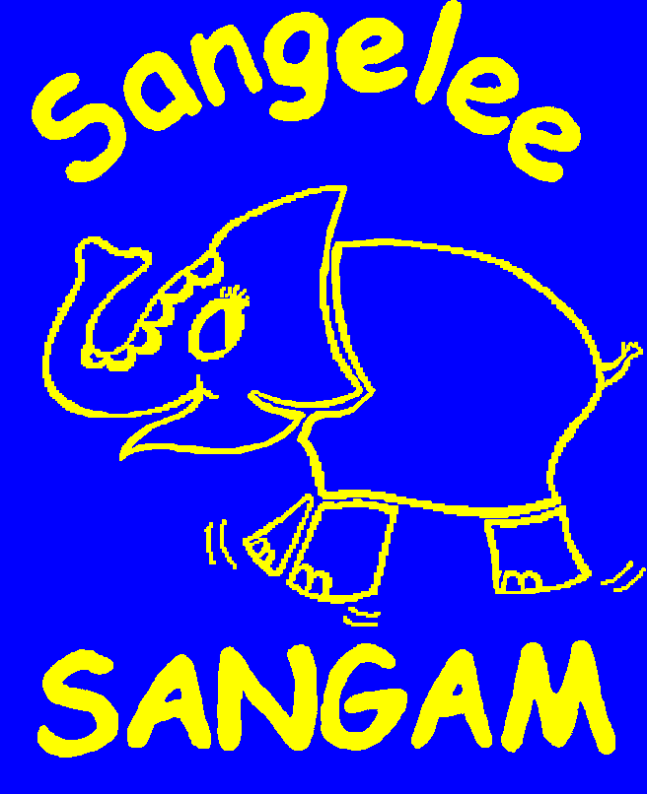

Robert Stephenson Smyth Baden-Powell
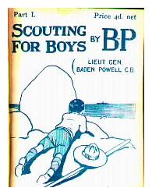
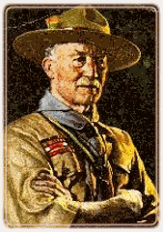
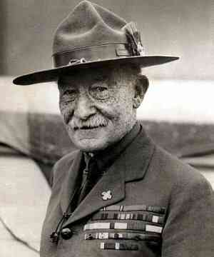
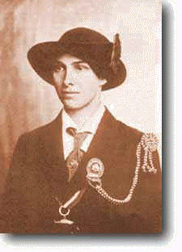
Olave Baden-Powell
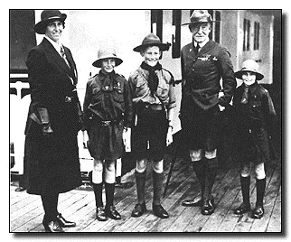
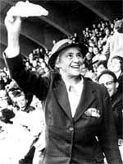
Juliette Low World Friendship Fund
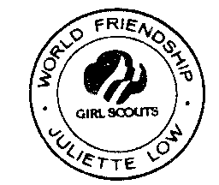
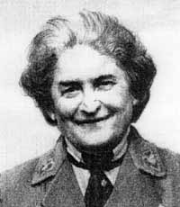
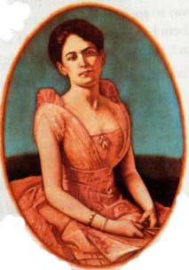
WAGGGS – World Association of Girl Guides and Girl Scouts
